 | FPT – ACADEMY INTERNATIONAL  CENTE NAME: FPT – APTECH 02  590 CMT8, DIS 03, HCM City | 

ONLINE POST OFFICE
MANAGEMENT SYSTEM

Approved By | Mr. NGUYEN QUAN THANH  Mr. TRUONG MAC CUONG
Batch No | F2-2007-0912-Y2
Group No | 04
Students |  | Full Name. | Roll No.
 | 1. | LE TAN DAT | VN.033/200805/0090
 | 2. | QUAN BUU MINH | VN.033/200807/0150
 | 3. | VU MINH TUAN | VN.033/200809/0283
 | 4. | NGUYEN TAN  CAT TUONG | VN.033/200808/0170

MAY 2010

ACKNOWLEDGEMENTS

This application, TARS online Post Office Management System, is designed and built as requested by TARS Company, a postal organization with different branches at different cities delivering the mails through various options like courier, speed post, Normal post, VPP and money orders….for the purpose of easy and efficient service, personnel and data management.
This online application provides a convenient way for TARS Delivery Company in dealing with their customers, as well as keeping the whole large records of deliverables and personnel. For customers, the application can help them find their everyday needs in delivering an email, or packages, even business contracts to someone, or to some locations…
We wish to acknowledge the valuable critical assistance given us by many teachers, especially Mr. Nguyen Quan Thanh and Mr. Truong Mac Cuong who contributed suggestions and instructions, and comments throughout the whole process of this project. Besides, we would like to thank the FPT faculty for providing us material facilities and guiding in conducting our project.

Group 04:
LE TAN DAT
QUAN BUU MINH
VU MINH TUAN
NGUYEN TAN CAT TUONG
Table of Contents
REVIEW 01
1.1. Introduction. 6
1.2. Existing scenario. 6
1.3. Customer Requirement Specifications. 7
1.4. Functional Requirement Specifications. 10
1.5. System Requirement. 16
1.5.1. Hardware 16
1.5.2. Software 16
1.6. Development Software. 17
1.7. Technology. 17
REVIEW 02
2.1. Use Case Diagram. 21
2.1.1. Use Case for Customer 21
2.1.2. Use Case for Employee 21
2.1.3. Use Case for Admin 22
2.2. Use Case Description. 23
2.2.1. Customer 23
2.2.2. Employee 27
2.2.3. Admin 29
2.3. Sequence Diagram. 33
2.3.1. Customer 33
2.3.2. Employee 34
2.3.3. Admin 35
2.4. Entity Relationship Diagram (ERD). 36
2.5. Entity Description. 37
2.6. Table Design. 41
2.7. Table Relationship Diagram. 47
REVIEW 03
3.1. Site Map 50
3.1.1. Customers Site Map 50
3.1.2. Admin Site Map 51
3.1.3. Eployee Site Map 52
3.2. Web Form Design 53
3.2.1. Customer 54
3.2.2. Admin 57
3.2.3. Employee 58

REVIEW 01

Introduction.
TARS Delivery System is a postal organization with different branches at different cities delivering the mails through various options like courier, speed post, Normal post, VPP etc… and money orders. They used to charge for the delivery of the mails based on the type of the service preferred, weight of the mail and as well based on the distance.

Existing scenario.
TARS Delivery System is a organization that has many of their branches at different cities. Currently, they are using a stand alone application that holds the details of the deliverables like the delivery number, date of posting, weight, type of delivery chosen, destination address, the address of the customer who has posted it, contact details,…. As soon as the packet is delivered, the date of receipt and the date of delivery are captured.
The problem is every each of their branches is using separate applications based on the locations. Now they need an online application incorporated in the system so that department people can use this same application.
This application can hold the details of the deliverables, the information of charges, Pin code, and the contact details based on the location. Furthermore, it can help customers in checking the delivering status for business purposes.

Customer Requirement Specifications.
The customer wants the online application to include the following task:
- There should be a separate login for the admin and as well as the users.
- The admin first creates username & password for the employees, and then the accounts are provided to the employees.
- Admin will have the following authorities :
- Insert, delete or search for the employees
- Accept request for changing profile from employees
- Declare, modify and delete offices
- Declare and adjust the services along with the charges.
- Check feedback from customers
- Employee will have the flowing rights :
- Change his/her password and update his/her account.
- Insert or edit the details of the deliverables
- See the details of the charges, contact information based on location, and the pin codes of the location.
- Cannot access details of the other employees.
- Customers have to provide the deliverable details at the time they are posting. The details of deliverables will include :
- The type of package(mails, parcels, forms, or money orders)
- Type of services they want to choose
- Weight
- Destination address
- The address of customers who are posting
- Contact details
After dropping the packages, customers are provided their Delivery number. If customers want to check their delivering status, they have to provide their Contact details that are provided at the time they have posted the package for the security purpose.
- Records are needed to be stored in the database based on location.
- On the homepage, the number of users registered and the number of users logged in are displayed at the top corner of the page.
- Also they should be able to find out what are to be delivered first based on the service chosen and the deliverables should be dispatched based on the type of service and then the details of dispatching, date of delivering it to the destination address should also be captured.
- Users can search the details through the using of Advanced Search option.
Financial:
The charges for the different services that they offer keep on varying based on the services preferred by their customers. The charge structure for the services that the TARS Delivery System offers is as follows.
No. | Service | Charges ($)
No. | Service | based on type of services  (1) | based on destination location  (2) | based on total weight  (3)
1 | Courier | 40 | 10 | 5
2 | Speed Post | 70 | 15 | 10
3 | Normal Post | 50 | 10 | 5
4 | VPP | 90 | 20 | 15
5 | Money Order | 60 | 15 | 5
.. | … | …. | … | ..
Total Charges = (1) + (2) + (3)

Functional Requirement Specifications.

Customers register as members.

Description
The system must provide a page to allow customer create account with following information:
First Name
Last Name
Email as a username for login to website
Password
Birthday
Sex
Address
Phone

Functional Requirements
REQ-01 Customer must provide First Name, Last Name, Email, Password, Birthday, Sex, Address and Phone.

Customer login to website

Description
The system must provide a page to customer login to website

Functional Requirements
REQ-02 Customer must provide Email, Password to login into website.
REQ-03 Customer can only access to pages they have permission.

The customer should be able to check the details of the deliverables

Description
The System must provide a page to customer to check the details of the deliverables. They can check by delivery PIN.

Functional Requirements
REQ-04 Customer must provide delivery PIN to check the details of the deliverables.

Customer search their deliveries PIN

Description
The System must provide a page to customer to search their deliveries Pin. They can search by their Email.

Functional Requirements
REQ-05 Customer must provide Email to search the list of their deliveries Pin.

The customers update their account information.

Description
The System must provide a page to customer to update their account with following information:
First Name
Last Name
Password
Birthday
Sex
Address
Phone

Functional Requirements
REQ-06 Customer can update their First Name, Last Name, Password, Birthday, Sex, Address and Phone.

Employees login to the website.

Description
The system must provide a page to employee login to website.

Functional Requirement
REQ-07 Employee must provide Email, Password to login into website.
REQ-08 Employee can only access to pages they have permission.

The employees update their account information.

Description
The System must provide a page to employee to update their account with following information:
First Name
Last Name
Password
Birthday
Sex
Address
Phone
Image

Functional Requirements
REQ-09 Employee can update their First Name, Last Name, Password, Birthday, Sex, Address, Phone and Image.

The employee only add or edit the details of the deliverables

Description
The System must provide a page to employee to add the details of the deliverables:
Add new customer account if the customer has not registered for an account.
If customer already has registered account, the employee just input an email of customer.
And input the details of the deliverables.
The System must provide a page to employee to edit the details of the deliverables.

Functional Requirements
REQ-10 Employee can check the account existed yet.
REQ-11 Employee add new customer account if the customer has not registered for an account.
REQ-12 Employee adds the details of the deliverables.
REQ-13 Employee edits the details of the deliverables.

The employees view the company's general information

Description
The System must provide:
A page to employee sees the details of the charges.
A page to employee sees contact information based on the location.
A page to employee sees the pin codes of the location.

Functional Requirements
REQ-14 Employee sees the details of the charges.
REQ-15 Employee sees contact information based on the location.
REQ-16 Employee sees the pin codes of the location.

Admin login to the website.

Description
The system must provide a page to admin login to website.

Functional Requirement
REQ-17 Admin must provide Email, Password to login into website.
REQ-18 Admin can access all pages of the website.

The Admin should be able to create the employee profiles

Description
The System must provide a page to Admin create the employee profiles.

Functional Requirements
REQ-19 Admin can create the employee profiles.
REQ-20 Admin can agree for the employees change their profiles.
REQ-21 Admin can delete the employee profiles.

Admin declare and modify the charges.

Description
The System must provide pages to Admin manage the charges.

Functional Requirements
REQ-22 Admin can declare the charges.
REQ-23 Admin can Admin modify the charges.
REQ-24 Admin can Admin delete the charges.

Admin declare and modify the information of Branches and Offices.

Description
The System must provide pages to Admin manage the Branches and Offices.

Functional Requirements
REQ-25 Admin can declare the Branches and Offices.
REQ-26 Admin can Admin modify the Branches and Offices.
REQ-27 Admin can Admin delete the Branches and Offices.

Admin check feedback.

Description
The System must provide pages to Admin manage the feedback

Functional Requirements
REQ-28 Admin can check the feedback.

System Requirement.

Hardware
- Web Server
Processor | PC Pentium IV 2.0 GHz or higher.
Memory | 256 MB or higher.
HDD | Free 20MB or higher.
Modem/ADSL | Connecting to internet 24/24

- Client
Processor | PC Pentium IV 2.0 GHz or higher.
Memory | 256 MB or higher.
HDD | Free 20MB or higher.
Monitor | Super VGA(800x600)
Pointing Device | Microsoft Mouse, IntelliMouse® or compatible pointing device.
Modem/ADSL | Connecting to internet.

Software
- Web Server
Operation System | Windows XP SP2 or higher.
Browsers | Internet Explorer 6.0 or higher
Database | Microsoft SQL Server 2005 Standard Edition
Software | Microsoft .NET Framework 3.0 or higher, Microsoft Silver light 2.0 or higher
- Client
Operation System | Windows XP SP2 or higher.
Bowers | Internet Explorer 6.0 or higher
Software | Microsoft Silver light 2.0 or higher, Adobe Flash Player 8 or higher.

Development Software.
- Microsoft Windows XP SP2.
- Microsoft Visual Studio 2008 SP1.
- Microsoft SQL Server 2005 Standard Edition.
- Microsoft Silverlight Tools 2.0.
- Notepad ++.
- Power Designer 15.1.
- Adobe Master Collection CS4.

Technology.
By adding new technologies such as ASP.NET 2.0, AJAX, Silver light 2.0… and 3-tier architecture, the web site becomes more interactive with users, security and easily updated.
Program is deployed on 3-tier model.
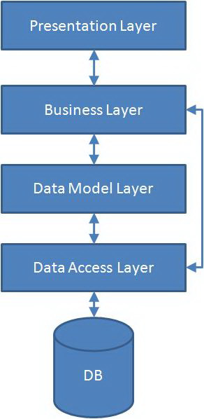

Presentation Layer: This tier is responsible for communication with the users and web service consumers and it uses objects from the business layer to respond to the GUI raised events.
Business Layer: This tier contains classes to calculate aggregated values like total revenue, payment etc... This tier doesn't know anything about the GUI controls and how to access databases. The classes of Data Access tier will supply the needy information from the databases to this tier.
Data Access Layer, Data Model Layer: This tier knows how to (from which database) retrieve and store information.
TASK SHEET REVIEW 01

Project  Ref. No. |  | Project Title | Activity Plan | Date of Preparation of Activity Plan
Sr. No | Task | Description | Planed Start Date | Actual Start Date | Actual Days | Team Mate Name | Status
1. | REVIEW-01 | Introduction. | 15-May-2010 | 15-May-2010 |  | All member of team | OK
2. | REVIEW-01 | Existing scenario |  |  |  |  | OK
3. | REVIEW-01 | Customer Requirement Specifications |  |  |  |  | OK
4. | REVIEW-01 | Functional Requirement Specifications |  |  |  |  | OK
5. | REVIEW-01 | System Requirement. |  |  |  |  | OK
6. | REVIEW-01 | Development Software |  |  |  |  | OK

 | Prepared By | Approved By
Signature | Mr. LE TAN DAT | Mr. TRUONG MAC CUONG
Date | 5 – Jun - 2010 | 5 – Jun - 2010

REVIEW 02

Use Case Diagram.

Use Case for Customer
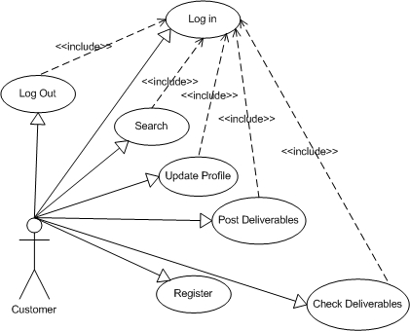

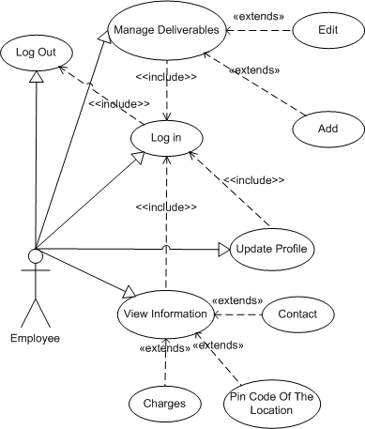
Use Case for Employee

Use Case for Admin
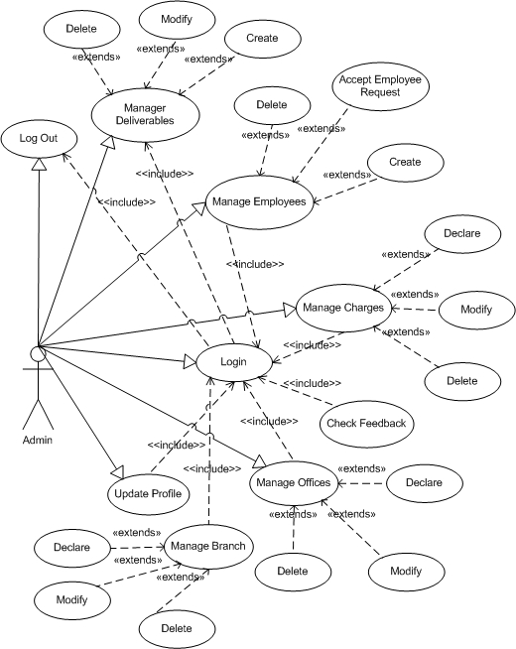

Use Case Description.

Customer
Usecase |  | Register
Short Description |  | Registration
Pre-Conditions |  | N/A
Post-Conditions |  | Success : new customer will be created and stored in database
Main flow |  | _ Customers must register the required information:  First Name  Last Name  Email (as a username for login to website)  Password  Birthday  Sex  Address  Phone  _ After providing the information, click the register button.  _ System will check the customer information provided.  _ System will store customer information in the database.
Alternative flow(s) |  | _ If the customer reset button, the system will automatically cancel the information logged.  _ If customers enter invalid, the system error.  _ Errors in entering registration information:  . Name and address not be less than 5 characters.  . Invalid email.  Invalid password  Invalid phone  . Any fields are blank.  _ System will automatically enter on customer registration.  _ After successful registration and posting, the system will inform customers.
Usecase | Posting Deliverables
Short Description | Customers must give details of their deliverables
Pre-Conditions | Customer must log in using his/her email and password
Post-Conditions | Success : deliverables will be posted to offices and stored in database
Main flow | _ Customers must login using their email(or PIN number), password  _ Then, customer can post their package. Their package must include the following information :  Type of package (email, form, parcel, or money order…)  Weight  Distance  _ Type of service chosen  _ System will store the details of deliverable.
Alternative flow(s) | _ Errors in entering details of deliverable :  Above or below the allowed weight  Above or below the allowed distance

Usecase | Login
Short Description | Customer can login to check delivering status
Pre-Conditions | Customer must have his/her email and password
Post-Conditions | N/A
Main flow | _ Customers must enter their email, or PIN number(if they forget their email) and password to login to the website  after the login, they can choose to :  can check the status of their deliverable through the delivery number  update their profiles  posting another package  _ System will provide the corresponding option
Alternative flow(s) | _ If the email or password is incorrect, the system error  _ If customers cannot remember their email (or PIN number), the system will inform a way to get back their email(or PIN number)

Usecase | Logout
Short Description | Customers can log out their current account
Pre-Conditions | Customer must log in using his/her email and password
Post-Conditions | N/A
Main flow | _ Customers log out their current account by pressing the logout button.  _ System will return to the homepage.
Alternative flow(s)

Usecase | Update Profile
Short Description | Customers can update their profile
Pre-Conditions | Customer must log in using his/her email and password
Post-Conditions | Success : new information will be stored in database
Main flow | _ After logging in, customers can update their account, like:  Change their email  Change their password  Change their name  Change their gender  Change their address  Change their phone  Change their birth date  _ Customers click the update button  _ Then, system will check the customer information  _ If the information is valid, system will update the new customer profile and inform the customers.  _The new details will be updated in database
Alternative flow(s) | If customers provide invalid information, system will inform errors
Usecase |  | Search
Short Description |  | Customers can search for their deliverables
Pre-Conditions |  | Customer must log in using his/her email and password
Post-Conditions |  | N/A
Main flow |  | _ Customers can choose the advanced search option that system provide  _ Customers must provide their Delivery Number to search for their deliverables  _ System provide the details of the corresponding deliverable
Alternative flow(s) |  | _ System will inform error deliverables not found if the delivery number is not matching.

Usecase | Checking Deliverables
Short Description | Customers can check their delivering status
Pre-Conditions | Customer must log in using his/her email and password
Post-Conditions | N/A
Main flow | _ Customer must provide their email(or PIN number) and password to login  _ After login, customer can check the status of delivering through the delivery number  _ System will provide the status of their corresponding deliverables
Alternative flow(s) | _If customer provide wrong email(or PIN number) or password, system will inform error  _If customer cannot remember their email(or PIN number) or password, system will inform a way for customer to get back their email(PIN number) or password

Employee
Usecase | Login
Short Description | Employee must provide their username and password to login
Pre-Conditions | N/A
Post-Conditions | Success : employees will have their respective rights
Main flow | _ First employee will receive username and password created by the admin  _ Then, they must enter their appropriate username and password to login  _ Employee click on Login button  _ System will return a page for employee  _ System will give them the appropriate authorities
Alternative flow(s) | _ If employee enter wrong username or password, system will inform error.

Usecase | Logout
Short Description | Employee can log out of their account
Pre-Conditions | Employee must log in using his/her email and password
Post-Conditions | N/A
Main flow | _ Employee can log out of their account by pressing the logout button  _ System will return them to the homepage
Alternative flow(s)

Usecase | Manage deliverables
Short Description | Employee can manage the details of deliverables after logging in
Pre-Conditions | Employee must log in using his/her email and password
Post-Conditions | Success : new deliverable details will be added
Main flow | After the login, employee can choose the following options:  View the details of the current deliverables  Add the details of the current deliverable  Edit the details of the current deliverable  System will provide a corresponding page for employee  System will check the new information entered  If the new details are valid, system will inform the employee and store the new details in database
Alternative flow(s) | System will inform error if the details entered are invalid

Usecase | Update Profile
Short Description | Employees can update their profiles
Pre-Conditions | Employee must log in using his/her email and password
Post-Conditions | N/A
Main flow | After login, employee can update their profile :  Their profile can be changed only after the admin accept their change request  New profile will be updated in database
  Employee Email
  Employee Password
  Employee First Name
  Employee Last Name
  Employee Birthday
  Employee Sex
  Employee Address
  Employee Phone
  Employee Image
Alternative flow(s) | System will inform error if the details entered are invalid

Usecase | View Information
Short Description | Employee can view the information
Pre-Conditions | Employee must log in using his/her email and password
Post-Conditions | N/A
Main flow | _After login, employee can choose to view the details of  Deliverables  Charges  Contacts  PIN code based on location  _System will provide the corresponding information
Alternative flow(s) | _System will inform error if employee choose to view the details of the other employees

ADMIN
Usecase | Login
Short Description | Admin must provide their username and password to log in
Pre-Conditions | N/A
Post-Conditions | Success : admin will be provided administrative rights
Main flow | Admin click on login button  System will return a page for the admin  Admin will be provided the appropriate authorities.
Alternative flow(s) | System will inform error if admin provide wrong username or password

Usecase | Logout
Short Description | Admin can log out of his/her account
Pre-Conditions | Admin must log in using his/her email and password
Post-Conditions | N/A
Main flow | admin click on the logout button ,system will return to homepage
Alternative flow(s)
Usecase |  | Manage Employees
Short Description |  | Admin has the rights to manage employees
Pre-Conditions |  | Admin must log in using his/her email and password
Post-Conditions |  | Success : new employee information will be created and stored in database
Main flow |  | _Admin can choose to :  Create a new username and password for employees  Deleting employees  Accepting update profile request from employees  _System will provide a corresponding page for the admin  _System will inform each employee their respective username and password  _System will update new details of employee  _New details of employee will be stored in database
Alternative flow(s) |  | System will inform error if admin enter invalid username or password.

Usecase | Manage Charges
Short Description | Admin can insert, delete, modify charges
Pre-Conditions | Admin must log in using his/her email and password
Post-Conditions | Success : new charges will be created and stored in database
Main flow | _Admin can have the following options :  Declare new charges  Modify charges  Delete charges  _ System will provide the corresponding page for admin  _ System will check for the new information  _ New details will be stored in database
Alternative flow(s) | System will inform error if admin enter invalid charges

Usecase | Manage Branch
Short Description | Admin has the option to manage Branches
Pre-Conditions | Admin must log in using his/her email and password
Post-Conditions | Success : New branches will be created and stored in database
Main flow | _ Admin can choose to :  Declare new Branches  Modify Branches  Delete Branches  _ System will provide a respective page for admin  _ System will check for the new information  _ New details will be stored in database
Alternative flow(s) | _System will inform error if admin enters invalid details of Branches

Usecase | Update Profile
Short Description | Admin can update his/her profile
Pre-Conditions | Admin must log in using his/her email and password
Post-Conditions | Success : Details will be saved in database
Main flow | _Admin can choose to update his/her profile :  Email  Password  First Name  Last Name  Birthday  Sex  Address  Phone  _System will provide the corresponding page  _System will check for the new information  _The new details will be updated in database
Alternative flow(s) | _System will inform error if admin enter invalid information

Usecase | Check Feedback
Short Description | Admin can check feedbacks from customers
Pre-Conditions | Admin must log in using his/her email and password
Post-Conditions | N/A
Main flow | _Admin can choose to check feedback from customers  _System will provide the corresponding page displaying customers’ feedbacks
Alternative flow(s)

Sequence Diagram.

Customer
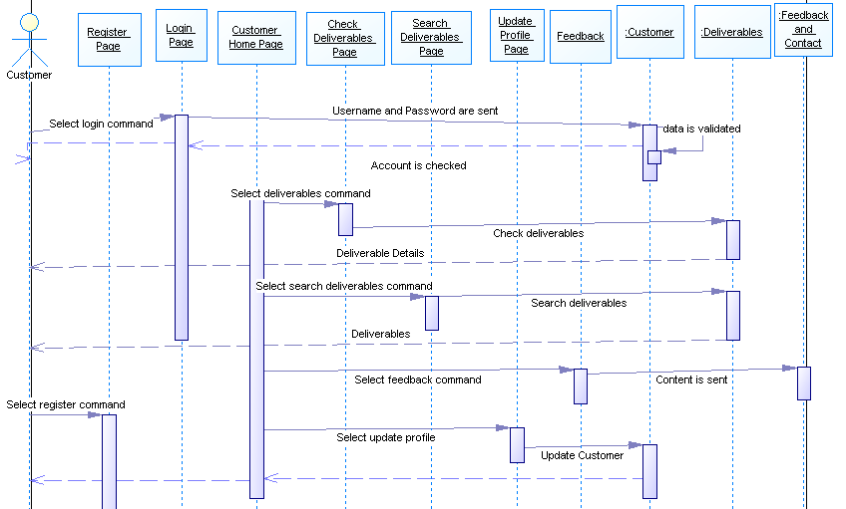

Employee
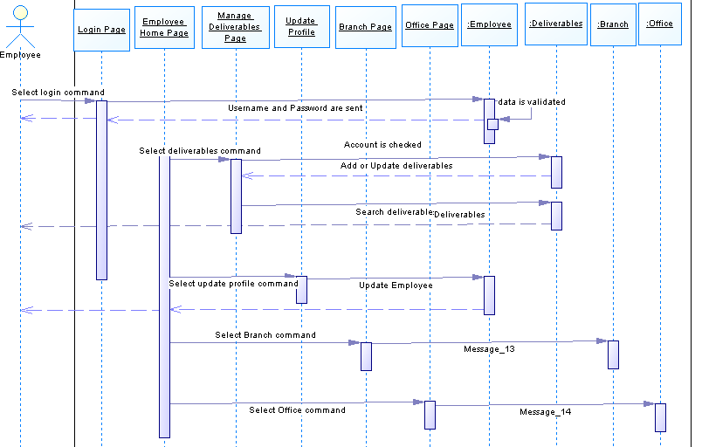

Admin
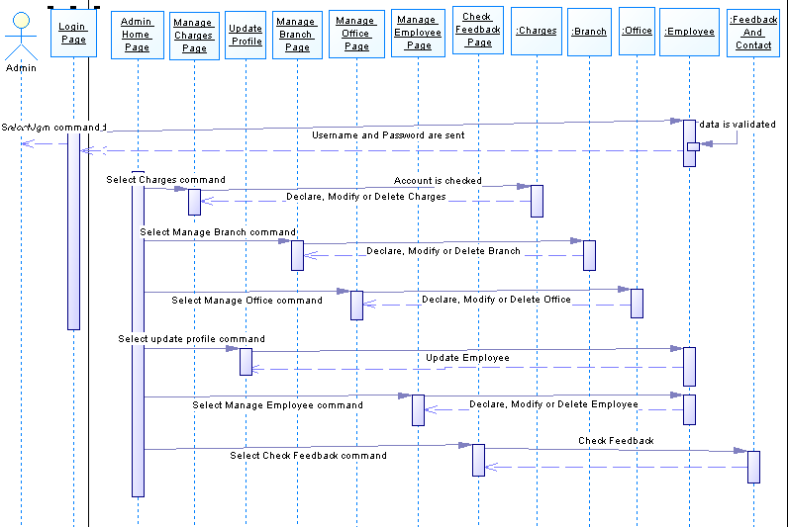

Entity Relationship Diagram (ERD).

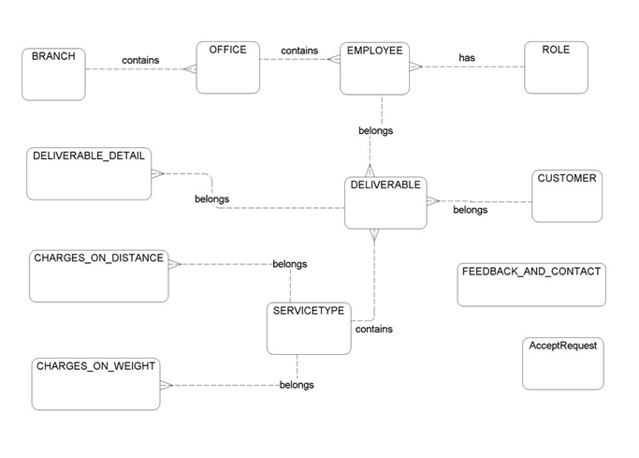

Entity Description.

BRANCH
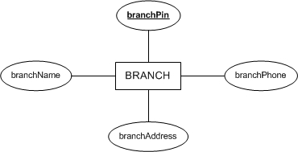

OFFICE
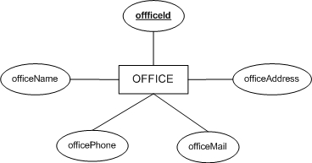

ROLES
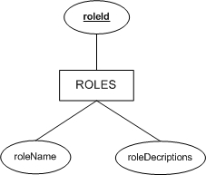

EMPLOYEE
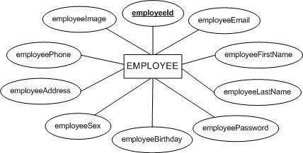

CUSTOMER
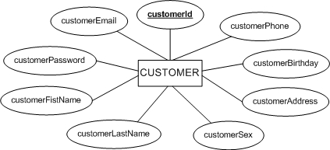

AcceptRequest
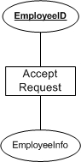

DELIVERABLE
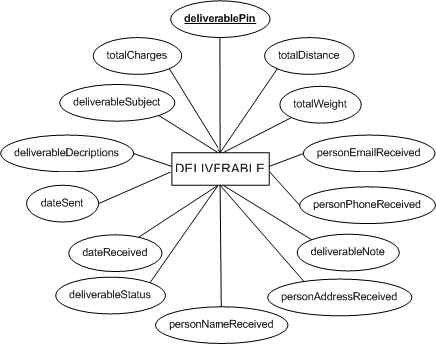

SERVICETYPE
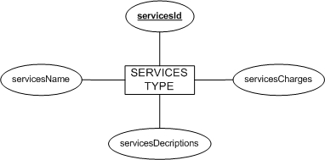

CHARGES_ON_WEIGHT
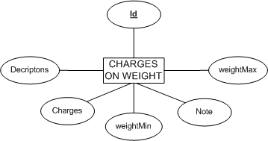

CHARGES_ON_DISTANCE
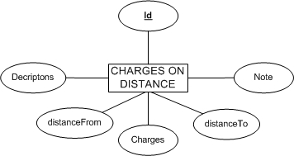

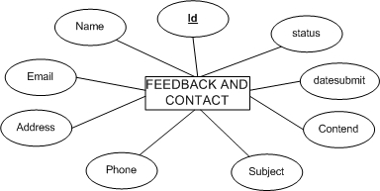
FEEDBACK_AND_CONTACT

Table Design.

BRANCH : describes details of branches including : PIN, Name,…
No | Column Name | Data Type | Size | Check | Description
1 | branchPin | varchar | 10 | Not Null | PIN code based on location
2 | branchName | varchar | 50 | Not Null | Name of branch
3 | branchAddress | varchar | 250 | Null | Address of branch
4 | branchPhone | varchar | 20 | Null | Phone of branch

OFFICE: describes details of offices including : Name, Address, Phone, Mail, PIN
No | Column Name | Data Type | Size | Check | Description
1 | offficeId | varchar | 10 | Not Null | Office ID
2 | officeName | varchar | 50 | Not Null | Name of office
3 | officeAddress | varchar | 250 | Not Null | Address of office
4 | officePhone | varchar | 20 | Not Null | Phone of office
5 | officeMail | varchar | 50 | Not Null | Mail address of office
6 | branchPin | varchar | 10 | Not Null | PIN code of branch based on location

ROLE: refers to the role of the user logged in
No | Column Name | Data Type | Size | Check | Description
1 |  roleId | varchar | 20 | Not Null | Role ID
2 | roleName | varchar | 50 | Not Null | Name of user after login
3 | roleDecriptions | varchar | 250 | Null | Details of user after login

EMPLOYEE: describes details of employees including :Email, Password, First Name, LastName, Birthday, Sex, Address, Phone, Image, Office ID, Role ID
No | Column Name | Data Type | Size | Check | Description
1 |  employeeId | varchar | 10 | Not Null | Employee ID
2 | employeeEmail | varchar | 50 | Not Null | Email of employee
3 | employeePassword | varchar | 50 | Not Null | Password of employee
4 | employeeFirstName | varchar | 50 | Not Null | First name of employee
5 | employeeLastName | varchar | 50 | Not Null | Last name of employee
6 | employeeBirthday | datetime |  | Not Null | Birth date of employee
7 | employeeSex | bit |  | Not Null | Gender of employee
8 | employeeAddress | varchar | 250 | Not Null | Address of employee
9 | employeePhone | varchar | 20 | Null | Phone of employee
10 | employeeImage | varchar | 50 | Null | Display picture of employee
11 | offficeId | varchar | 10 | Not Null | Office ID
12 | roleId | varchar | 10 | Not Null | Role ID

CUSTOMER: describes details of customerss including :Email, Password, First Name, LastName, Birthday, Sex, Address, Phone
No | Column Name | Data Type | Size | Check | Description
1 |  customerId | varchar | 10 | Not Null | Customer ID
2 | customerEmail | varchar | 50 | Not Null | Email of customer
3 | customerPassword | varchar | 50 | Not Null | Password of customer
4 | customerFistName | varchar | 50 | Not Null | First name of customer
5 | customerLastName | varchar | 50 | Not Null | Last name of customer
6 | customerBirthday | datetime |  | Null | Birth date of customer
7 | customerSex | bit |  | Null | Gender of customer
8 | customerAddress | varchar | 250 | Not Null | Address of customer
9 | customerPhone | varchar | 20 | Null | Phone of customer

SERVICESTYPE: describes details of services like : ID, Name, Desciption, Charges
No | Column Name | Data Type | Size | Check | Description
1 |  servicesId | varchar | 10 | Not Null | Service ID
2 | servicesName | varchar | 50 | Not Null | Name of service
3 | servicesDecriptions | varchar | 250 | Null | Details of service
4 | servicesCharges | float |  | Not Null | Charges of service

DELIVERABLE: describes information of deliverables
No | Column Name | Data Type | Size | Check | Description
1 | deliverablePin | varchar | 10 | Not Null | PIN code of deliverable
2 | customerSent | varchar | 10 | Not Null | ID of customer who
3 | deliverableSubject | varchar | 50 | Not Null | Subject of deliverable
4 | deliverableDecriptions | varchar | 250 | Null | Details of deliverable
5 | dateSent | datetime |  | Not Null | Date of sending deliverable
6 | dateReceived | datetime |  | Null | Date of receive deliverable
7 | personNameReceive | varchar | 50 | Not Null | Name of person who receive the deliverable
8 | personAddressReceive | varchar | 250 | Not Null | Address of person who receive the deliverable
9 | personPhoneReceive | varchar | 20 | Null
10 | personEmailReceive | varchar | 50 | Null
11 | totalWeight | float |  | Not Null | Weight of deliverable
12 | totalDistance | float |  | Not Null | Distance of delivering
13 | totalCharges | float |  | Not Null | Total charges
14 | deliverableStatus | bit |  | Not Null | Status of deliverable
15 | deliverableNote | varchar | 250 | Null | Note
16 | servicesType | varchar | 10 | Not Null | Type of service
17 | employeeId | varchar | 10 | Not Null | Employee ID

DELIVERABLE_DETAIL: displays details of Deliverables including ID, PIN, Name, Weight, Descriptions, Note,…
No | Column Name | Data Type | Size | Check | Description
1 |  detailId | varchar | 10 | Not Null | Detail ID
2 | deliverablePin | varchar | 10 | Not Null | PIN code of deliverable
3 | deliverableName | varchar | 50 | Not Null | Name of deliverable
4 | deivrableWeight | float |  | Not Null | Total weight of deliverable
5 | Decriptions | varchar | 250 | Null | Details of deliverable
6 | Note | varchar | 250 | Null | Note

CHARGES_ON_WEIGHT: displays details of charges on weight including Descriptions, Minimum Weight, Maximum Weigth, Charges, Note and Types of Services.
No | Column Name | Data Type | Size | Check | Description
1 |  Id | varchar | 10 | Not Null | ID of charge
2 | Decriptons | varchar | 250 | Not Null | Description of weight charge
3 | weightMin | float |  | Not Null | Minimum of weight
4 | weightMax | float |  | Not Null | Maximum of weight
5 | Charges | float |  | Not Null | Charge on weight
6 | Note | varchar | 10 | Null | Note
7 | servicesType | varchar | 10 | Not Null | Type of service preferred

CHARGES_ON_DISTANCE: displays details of charges on distance including Descriptions, Distance From, Distance To, Charges, Note and Types of Services.
No | Column Name | Data Type | Size | Check | Description
1 |  Id | varchar | 10 | Not Null | ID of charge
2 | Decriptons | varchar | 250 | Not Null | Description of distance charge
3 | distanceFrom | float |  | Null | Place of sending
4 | distanceTo | float |  | Null | Destination of receiving
5 | Charges | float |  |  | Charge on distance
6 | Note | varchar | 250 |  | Note
7 | servicesType | varchar | 10 |  | Type of service preferred

FEEDBACK_AND_CONTACT: displays the details of user’s feedback and contact including Name, Email, Address, Phone, Subject of feedback and Content of feedback .
No | Column Name | Data Type | Size | Check | Description
1 |  Id | varchar | 10 | Not Null | ID of person who sends feedback
2 | Name | varchar | 50 | Not Null | Name of person who sends feedback
3 | Email | varchar | 50 | Not Null | Email of person who sends feedback
4 | Address | varchar | 250 | Not Null | Address of person who sends feedback
5 | Phone | varchar | 20 | Null | Phone of person who sends feedback
6 | Subject | varchar | 50 | Not Null | Subject of feedback
7 | Content | varchar | 250 | Not Null | Content of feedback

COUNT_VISIT: displays the number of customers visited
No | Column Name | Data Type | Size | Check | Description
1 | count | int |  | Not Null | Count the number of users visting the webiste

AcceptRequest: displays the details of employees asking for request including : ID and Employee Information
No | Column Name | Data Type | Size | Check | Description
1 |  Id | INT | 10 | Not Null
2 | EmployeeInfo | XML |  | Not Null | Information of Employee

Table Relationship Diagram.
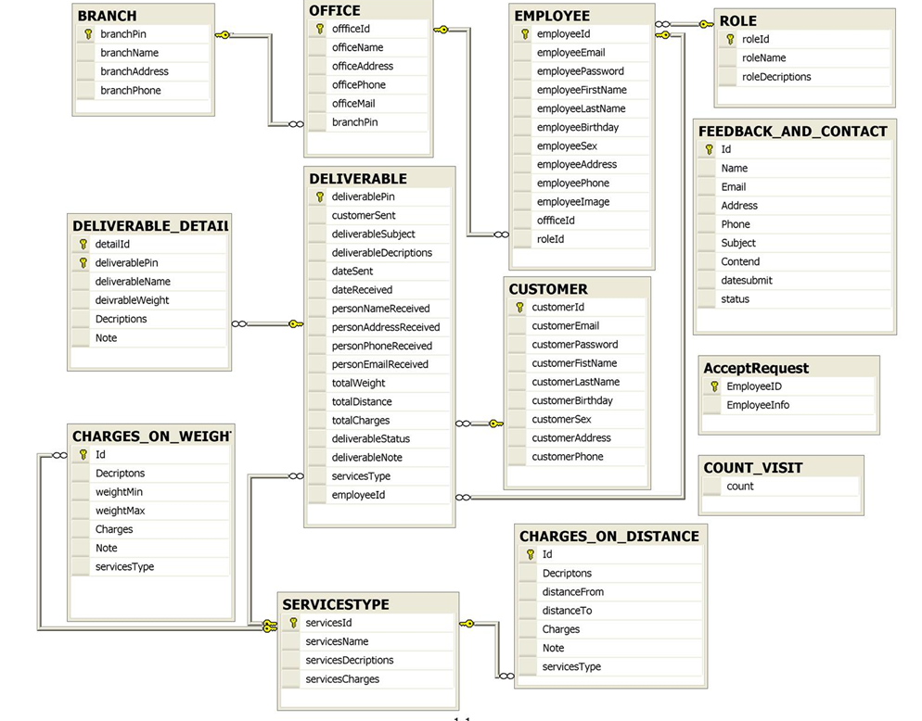

TASK SHEET REVIEW 02

Project  Ref. No. |  | Project Title | Activity Plan | Date of Preparation of Activity Plan
Sr. No | Task | Description | Planed Start Date | Actual Start Date | Actual Days | Team Mate Name | Status
1. | REVIEW-02 | Use Case Diagram. | 22-May-2010 | 22-May-2010 |  | All member of  team | OK
2. | REVIEW-02 | Use Case Description |  |  |  |  | OK
3. | REVIEW-02 | Sequence Diagram |  |  |  |  | OK
4. | REVIEW-02 | Entity Relationship Diagram |  |  |  |  | OK
5. | REVIEW-02 | Entity Description |  |  |  |  | OK
6. | REVIEW-02 | Table Design |  |  |  |  | OK
7. | REVIEW-02 | Table Relationship Diagram. |  |  |  |  | OK

 | Prepared By | Approved By
Signature | Mr. LE TAN DAT | Mr. TRUONG MAC CUONG
Date | 5- Jun -2010 | 5- Jun -2010

REVIEW 03

Site Map

Customers Site Map
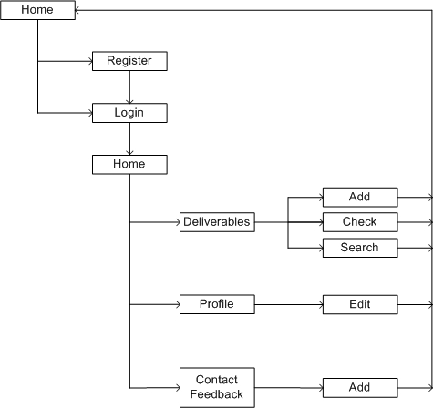

Admin Site Map
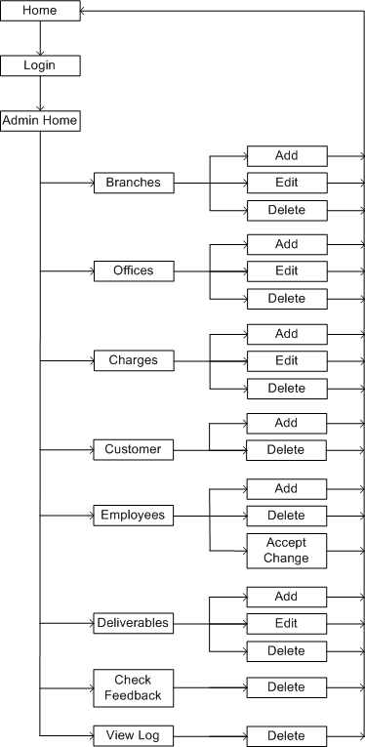

Eployee Site Map
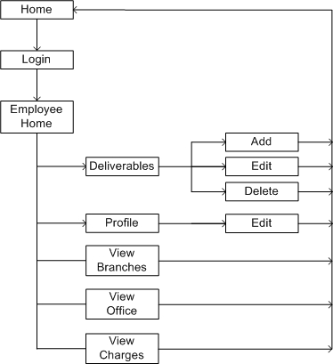

Web Form Design
- Home Page
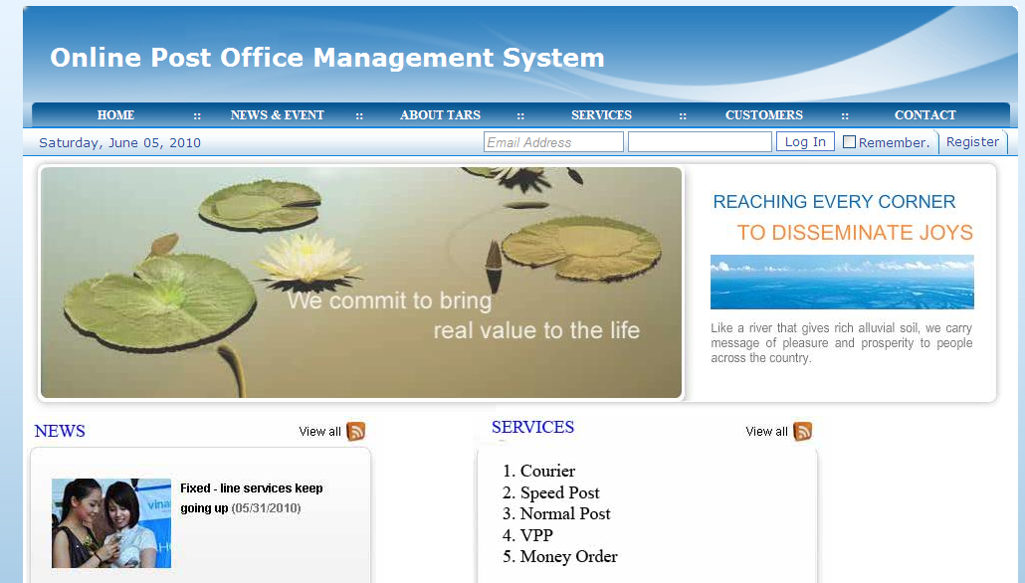

Customer

Register
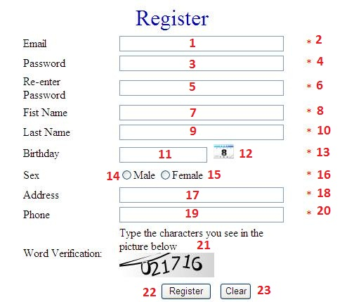
REGISTER
No | Type | Null | Validation | Description
1 | Textbox | NO | Must match \w+([-+.']\w+)*@\w+([-.]\w+)*\.\w+([-.]\w+)* | Email
2 | Validation |  |  | Email Validation
3 | Textbox | NO |  | Password
4 | Validation |  |  | Password Validation
5 | Textbox | NO |  | Re-password
6 | Validation |  |  | Re-password Validation
7 | Textbox | NO |  | First Name
8 | Validation |  |  | Name Validation
9 | Textbox | NO |  | Last Name
10 | Validation |  |  | Name Validation
11 | Textbox | NO |  | Birth date
12 | Custom control Calendar |  |  | calendar
13 | Validation |  |  | Date validation
14 | Radio Button |  |  | Gender(Male)
15 | Radio Button |  |  | Gender(Female)
16 | Validation |  |  | Gender Validation
17 | Textbox | NO |  | Address
18 | Validation |  |  | Address validation
19 | Textbox | NO | Must match “^\\d+(-\\d+){2}$” | Phone number
20 | Validation |  |  | Phone Validation
21 | Textbox |  |  | Word Verification
22 | Button |  |  | Register
23 | Button |  |  | Reset all the fields

Contact & feedBack
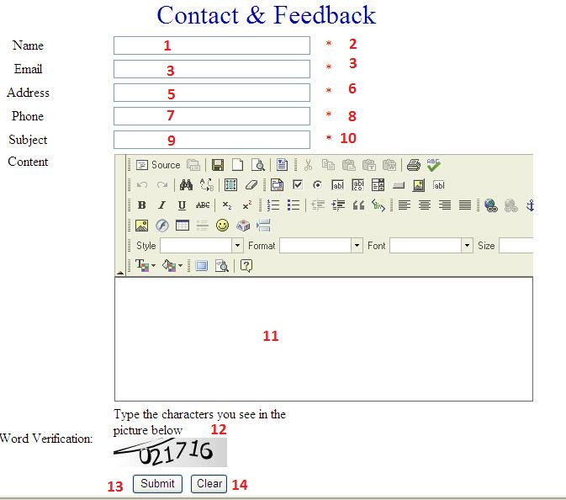
FEEDBACK
No | Type | Null | Validation | Description
1 | Textbox | NO |  | Name
2 | Validation |  |  | Name Validation
3 | Textbox | NO | Must match \w+([-+.']\w+)*@\w+([-.]\w+)*\.\w+([-.]\w+)* | Email
4 | Validation |  |  | Email Validation
5 | Textbox | NO |  | Address
6 | Validation |  |  | Address Validation
7 | Textbox | NO | Must match “^\\d+(-\\d+){2}$” | Phone number
8 | Validation |  |  | Phone Validation
9 | Textbox | NO |  | Subject
10 | Validation |  |  | Name Validation
11 | TextField | NO |  | Feedback Content
12 | textField | NO |  | Word Verification
13 | Button |  |  | Submit feedback
14 | Button |  |  | Reset fields

Admin

Home
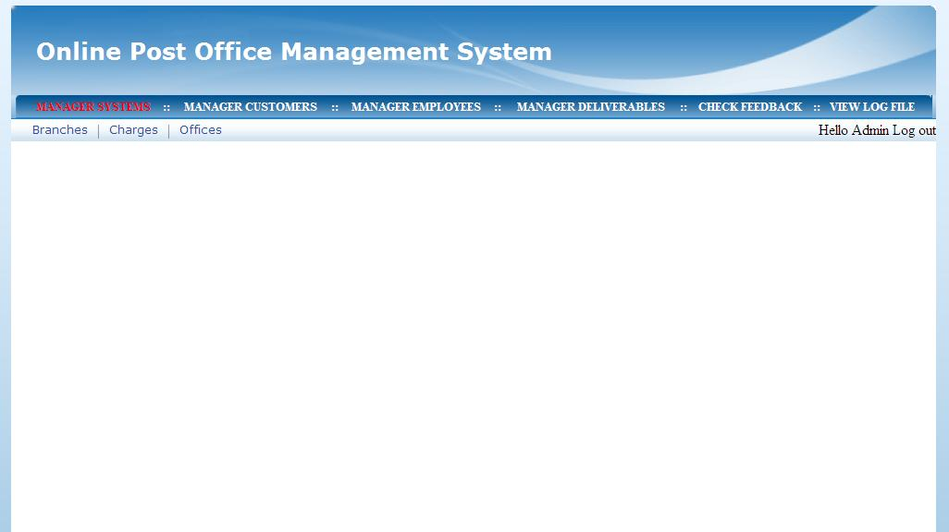

Manager Braches
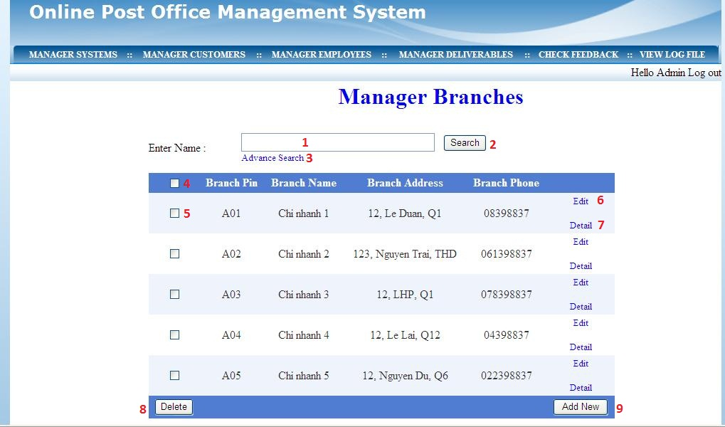
Manager Branches
No | Type | Null | Validation | Description
1 | Textbox | Not null |  | Users can enter name of branch they want to search for
2 | Button |  |  | Search branch
3 | Label |  |  | Search advance option
4 | Checkbox |  |  | Check all the list
5 | Checkbox |  |  | Check each type of branch
6 | Label |  |  | Edit details of a branch
7 | Label |  |  | View details of a branch
8 | Button |  |  | Delete branches chosen
9 | Button |  |  | Insert a new branch

Add Employee
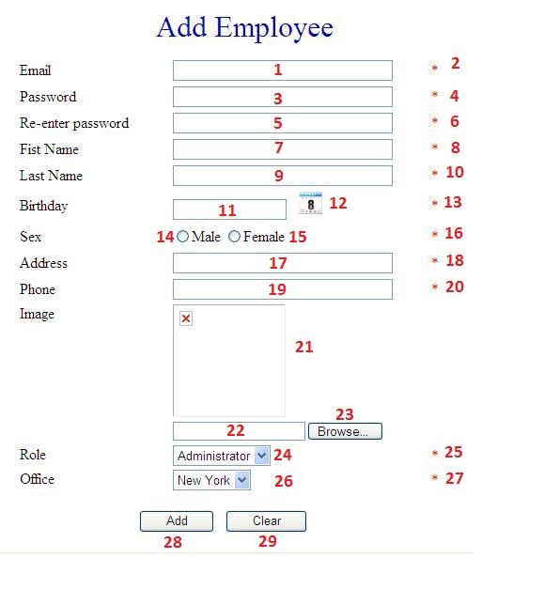
ADD EMPLOYEE
No | Type | Null | Validation | Description
1 | Textbox | NO | Must match \w+([-+.']\w+)*@\w+([-.]\w+)*\.\w+([-.]\w+)* | Email
2 | Validation |  |  | Email Validation
3 | Textbox | NO |  | Password
4 | Validation |  |  | Password Validation
5 | Textbox | NO |  | Re-password
6 | Validation |  |  | Re-password Validation
7 | Textbox | NO |  | First Name
8 | Validation |  |  | Name Validation
9 | Textbox | NO |  | Last Name
10 | Validation |  |  | Name Validation
11 | Textbox | NO |  | Birth date
12 | Custom control Calendar |  |  | calendar
13 | Validation |  |  | Date validation
14 | Combo box | NO |  | Gender(Male)
15 | Combo box | NO |  | Gender(Female)
16 | Validation |  |  | Gender Validation
17 | Textbox | NO |  | Address
18 | Validation |  |  | Address validation
19 | Textbox | NO | Must match “^\\d+(-\\d+){2}$” | Phone number
20 | Validation |  |  | Phone Validation
21 | Image |  |  | Picture display
22 | Textbox |  |  | Path of image
23 | Button |  |  | browse images from computer
24 | Drop down list |  |  | Role
25 | Validation |  |  | Role Validation
26 | Drop down list |  |  | Office
27 | Validation |  |  | Office Validation
28 | Button |  |  | Insert new employee
29 | Button |  |  | Reset all the fields

Accept Change Profile of Employee
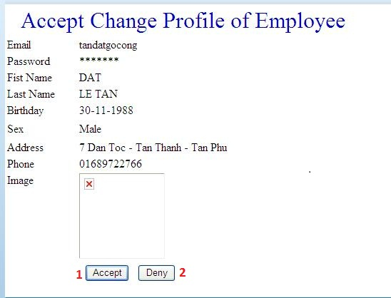
ACCEPT CHANGE EMPLOYEE PROFILE
No | Type | Null | Validation | Description
1 | button |  |  | Accept change of employee profile
2 | button |  |  | Deny change of employee profile

Employee

Upate Profile
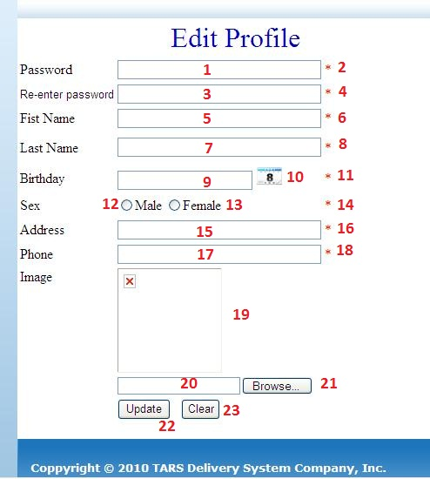
EDIT PROFILE
No | Type | Null | Validation | Description
1 | Textbox | NO |  | Password
2 | Validation |  |  | Password Validation
3 | Textbox | NO |  | Re-password
4 | Validation |  |  | Re-password Validation
5 | Textbox | NO |  | First Name
6 | Validation |  |  | Name Validation
7 | Textbox | NO |  | Last Name
8 | Validation |  |  | Name Validation
9 | Textbox | NO |  | Birth date
10 | Custom control Calendar |  |  | calendar
11 | Validation |  |  | Date validation
12 | Radio Button |  |  | Gender(Male)
13 | Radio Button |  |  | Gender(Female)
14 | Validation |  |  | Gender Validation
15 | Textbox | NO |  | Address
16 | Validation |  |  | Address validation
17 | Textbox | NO | Must match “^\\d+(-\\d+){2}$” | Phone number
18 | Validation |  |  | Phone Validation
19 | Image |  |  | Picture display
20 | Textbox |  |  | Path of image
21 | Button |  |  | browse images from computer
22 | Button |  |  | Update employee
23 | Button |  |  | Reset all the fields

TASK SHEET REVIEW 03

Project  Ref. No. |  | Project Title | Activity Plan | Date of Preparation of Activity Plan
Sr. No | Task | Description | Planed Start Date | Actual Start Date | Actual Days | Team Mate Name | Status
1. | REVIEW-03 | Customers Site Map | 22-May-2010 |  |  | All member of  team | OK
2. | REVIEW-03 | Admin Site Map |  |  |  |  | OK
3. | REVIEW-03 | Eployee Site Map |  |  |  |  | OK
4. | REVIEW-03 | Web Form Design |  |  |  |  | OK
5.
6.
7.

 | Prepared By | Approved By
Signature | Mr. LE TAN DAT | Mr. TRUONG MAC CUONG
Date | 5- Jun -2010 | 5- Jun -2010

